Events
Events are the logging facilities of EVM that can be used to retrieve information about the transaction and contract. Events notify the applications about the change made to the contracts and applications which can be used to execute the dependent logic.
Suppose you are doing a smart contract transaction from your application like changing some variable in the transaction and you want to log information of other variables in the contract you can do it with events.
An event is an inheritable member of a contract. An event is emitted(triggered), and it stores the arguments passed in transaction logs. These logs are stored on the blockchain and are accessible using the address of the contract till the contract is present on the blockchain. An event generated is not accessible from within contracts as it is not part of it, its a total different entity than the contract.
This is how you define an event
event Students(string name, uint id);
Now that event is defined we just have to emit it,
string std_name;
uint std_id;

event Students(string name, uint id);

function change(string memory arg1, uint arg2) public {
std_name = arg1;
std_id = arg2;
emit Students(arg1, arg2); // emit Students(std_name, std_id); -> also works
}
You can use events functionality for logging anything, You just have to specify while defining event what properties you want to log and then emit them in any function according to your use.
Let's call the above function with values ('naruto', 7)
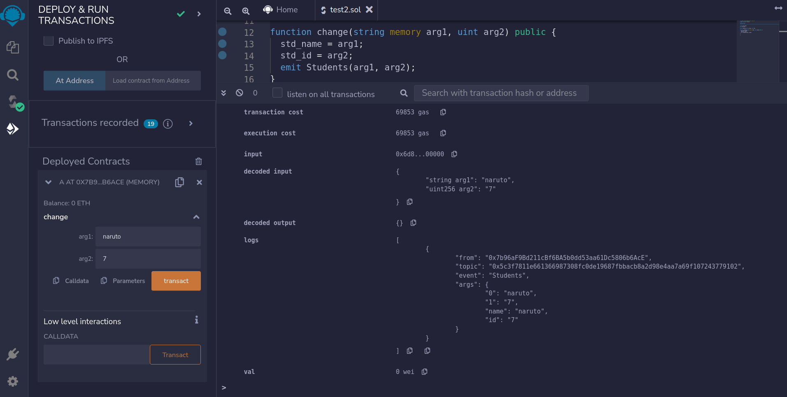
As you can see, in Logs we can find (naruto, 7) stored as per our defined and emitted event emit Students(arg1, arg2) in function change().
This log is a special data structure in the blockchain. These logs are associated with the address of the contract, are incorporated into the blockchain, and stay there as long as a block is accessible. The Log and its event data are not accessible from within contracts, you can only obtain them from your application externally or from an Ethereum client or Ethereum node.
You might have observed while interacting with a deployed smart contract that every transaction you do while using a non-payable or payable function that it needs confirmation and takes time. First, the transaction is created on the user's side and then this transaction is sent to the blockchain network and is then confirmed by nodes on the blockchain network and then you will see the output of your transaction. You can use events there as well which will notify you when your transaction is complete and give you logs for the events you created.

Topics
You can add the attribute indexed to up to three parameters which adds them to a special data structure known as topics instead of the data part of the log. A topic can only hold a single word ie. 32 bytes, so if you use a reference type for an indexed argument, the Keccak-256 hash of the value is stored as a topic instead.
All parameters without the indexed attribute are ABI-encoded into the data part of the log.
Topics allow you to search for events, for example when filtering a sequence of blocks for certain events. You can also filter events by the address of the contract that emitted the event.

Events
An event is an inheritable member of a contract. An event is emitted(triggered), and it stores the arguments passed in transaction logs. These logs are stored on the blockchain and are accessible using the address of the contract till the contract is present on the blockchain. An event generated is not accessible from within contracts as it is not part of it, it's a total different entity than the contract.
This is how you define an event -
event Students(string name, uint id);
Now that event is defined we just have to emit it,
string std_name;
uint std_id;

event Students(string name, uint id);

function change(string memory arg1, uint arg2) public {
std_name = arg1;
std_id = arg2;
emit Students(arg1, arg2); // emit Students(std_name, std_id); -> also works
}
You can use events functionality for logging anything, You just have to specify while defining events what properties you want to log and then emit them in any function according to your use.

Hint :

// SPDX-License-Identifier: MIT
pragma solidity ^0.8.10;

contract A {
event Deposit(
uint8 indexed id,
uint value
);

function deposit(uint8 id) public payable {
emit Deposit(id, msg.value);
}
}

